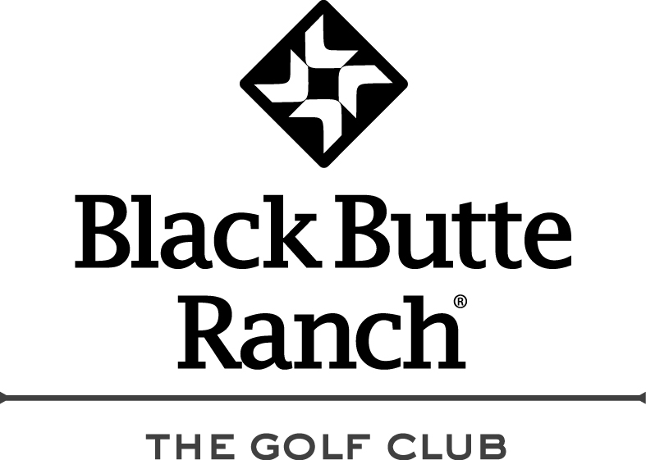
BBR Women’s Club Results
August 25th, 2020
O-N-E-S

1st Place w/ 34 $15.00
Judie Johnson

2nd Place w/ 35 $11.00
Anne Zick

3rd Place Tie w/ 36 $4.00 each
Paula Reents, Phillys Lees
& Meg Scanlan

13 x’s $3.00 = $39.00 payout

Thanks again,
Brian

